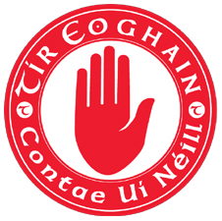
Tyrone GAA Summer Camps 2019
Tyrone Summer Camps are due to commence on the 1st July and will run through for 8 consecutive weeks with 51 camps being run across the county and the good news is that we have enhanced pay rates in operation for all coaches.
Tyrone GAA are looking for quality coaches for football, hurling and handball to help in ensuring that our camps are a success. Those who have completed their foundation level award, have coached or are coaching within their clubs youth programme and are looking to work in a fun environment then we want to hear from you.
Interested?
There will be an information and training evening held on Monday 10th June in the Tyrone GAA Centre in Garvaghey at 6.30 pm. Only those who attend this session will be eligible to work in the summer camps. All coaches are requested to bring suitable training gear as there will be a practical element.
The session will include a short ‘Code of Best Practice’ refresher and some practical information for working at camps. This will be followed by a practical session outdoors to go through fun games to use during the summer camps.
All coaches must be Access NI Vetted through Tyrone GAA and must be completed before Monday 3rd June.
For further information regarding summer camp coaching please contact brian.laverty.gdm.tyrone@gaa.ie or phone on 028 855 67723.

